**OPTITRACK MOTION CAPTURE (/3)**

**Part of a series**

1. **Quick start guide**
2. **Precision capture**

**Motion capture** is the discipline of tracking movements. It has usecases from film (to add CGI effects) to robotics (to find the position of robots). In my case, the Optitrack framework provided the means of detecting my drone’s position where **onboard methods would be too imprecise**. After all, Optitrack boasts of their **submillimetre accuracy**, stating that an accuracy of less than a third of a millimetre should be “more than manageable”.

This tutorial is meant to **upskill users** from Optitrack’s setup and first use, to more precise uses of the system. The framework builds around **optical motion capture**, which has its own set of benefits and challenges, and Optitrack offers solutions to improving **capture precision** in various usecases. Finally, since the tracked data is multicasted, setting up a **multicast client** is possible both in Windows and Ubuntu, and a few **troubleshooting skills** can help connect your particular application (mine is using **ROS for drone control**). Using this framework on the **drone arena** might require **maintenance of the arena**, which is covered in a separate tutorial.

Using troubleshooting techniques:

* Graphing for wobbles in position
* D

Quick comments on what precision is achieved, on site and via specs

Explaining more basic concepts: like the residual and why it’s a measure of precision.

Taking a low-latency estimate and ramping up the precision

* Waiting for initial heat up
* Precision Mode
* Lens refocus
* Lower residual threshold
* Higher circularity vs number of rays per marker
* No need to touch on marker size

Taking two cameras and calibrating them according to their position

* Maximum ray length
* Position vs Ray Angle: is it worth reducing angle to 30 degrees? See intersecting rays. Actually someone must have

Unusual phenomenon: marker wobble **and** marker too small **and** loses Solved component

* Exposure imprecision
* Increase THR setting

Equipment limitations:

* IR illumination
* D

Sequential output

* Taking down cameras and refocusing on the ground
* Adding them with care for pully strings, and pulling net backwards
* Placing the drones (turned on) on the carpet
* Turning on ROS
* Sliding down the net carefully
* Executing Python code

Things to be done (might be skewing these conclusions):

* Capture all the possible capture volume

# Section x: Precision capture theory

If the cameras are too close to one another, they can reflect IR light on one another, or on objects that are too close. Inversely, if they are too far, the IR light does not reach the object. The camera might also be out of focus at certain distances, which makes it difficult to differentiate markers from extraneous reflections. All these problems contribute to identifying if a reflection is in fact a marker, or distinguishing markers from each other.

Various solutions exist. First, we wish to have a clear image on the camera. The lens can be refocused. The LED intensity can be varied, as well as exposure. After these hardware solutions, the camera itself processes images with 2D Filters: discarding reflections if they do not fall in a correct size range (size threshold) and if they do not have sufficient circularity (minimum circularity). The THR setting or threshold for brightness, also determines the pixels based on their illumination intensity. What is interesting is that these filters are applied frame by frame, and therefore cannot benefit of any reconstruction over time.

Reconstruction is the process of deriving 3D points from the 2D coordinates that are obtained from camera images. This process first obtains centroid locations from one camera’s individual frames, and then use each camera’s centroid to triangulate a 3D position in the capture area. Various means of precision are done, and they stem from a 3D vector extending from each camera origin to its detected centroid, otherwise called a marker ray.

The average offset distance between the converging rays gives us a precision rating, called the residual value or mean residual. A maximum residual can be set as a “reconstruction” software setting. The length of the 3D vector also has importance, as “middle-range” lengths are preferred over “too-close” or “too far” (more likely to blur). Adding these two thresholds give two of the software filters post-reconstruction.

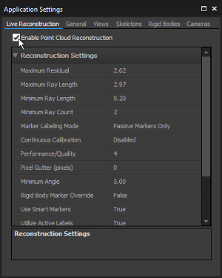

Having said this, there have been compromises that are made in the interest of reducing the amount of computation and thus risks to reduce system latency and system frame rate. The camera, by default, is in Object Mode, which means that 2D object metrics (the centroid location, the size of the markers and the roundness of the markers) are determined on-camera as the software filters mentioned earlier. This has the lowest processing latency as opposed to Precision Mode, where the marker reflections and centroid regions are sent to the host for more precise but more computationally expensive processing. This is acceptable in lower camera count environments.

The use of a camera in grayscale helps to understand what is going on, thus two Reference Modes are possible. MJPEG grayscale compresses images on-camera while raw grayscale remains uncompressed (to the risk of high streaming bandwidth).

It is worth noting that a 4x4 setup with full sunlight illumination has proven to work with results seen below (see calibration section below to understand the criteria). It is at your own discretion to check if markers are detected, ***via Motive’s grayscale option***. At the DVIC, we chose this second configuration as a more permanent option.

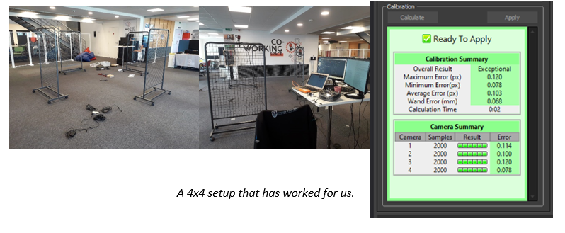

The IR reflections are not the only problem: bad camera configurations might blur the markers (poor lens focus) or contrast them poorly (poor exposure/threshold limit). This will end up affecting the calibration algorithm as it will compute the centroid of each marker badly, as seen below. For lens focus, you will need to open the camera’s front casing and adjust focus directly while comparing to live output on Motive.

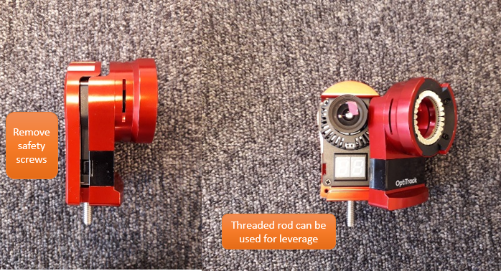

*Removing the camera cover for lens refocusing*

DVIC Note: the casing is fit very tightly, so be careful, these are $999 cameras. Ask for help from those who have focused the lens before.

DVIC Note 2: removing the casing also means there is no LED illumination of the markers. You might want to use a second camera to illuminate the markers.

Exposure and threshold values can be configured afterwards via Motive as such.

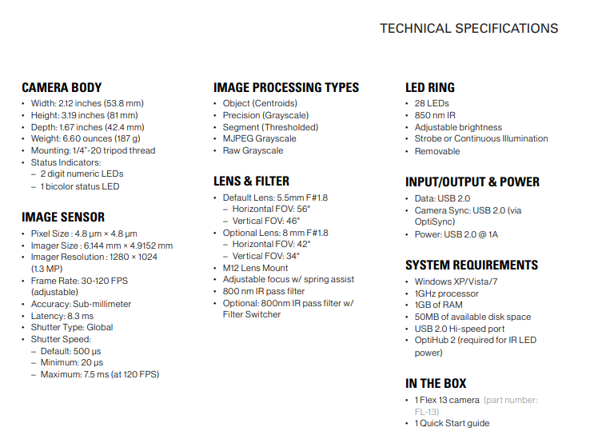

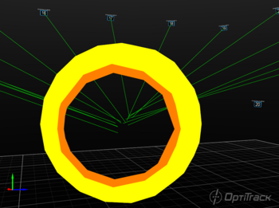 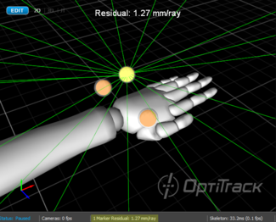

All these elements will have an effect on the computations during calibration. Before going into these, **we briefly overview the theory of precision capture to help us benchmark these calibrations.**

To define a

Residual error etc. Tabulated in the docs

### Camera specifications

